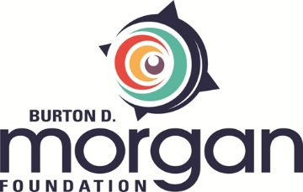

FINAL GRANT REPORTING FORM

This report is to be completed after all grant dollars have been expended.* Prior to completing the report, please review the objectives of the grant and take time to thoughtfully review the program with a variety of staff members. Reports are evaluated on how well your organization meets grant objectives, reflects on outcomes, and contributes to the Northeast Ohio entrepreneurship ecosystem.
Please email your completed form to Gina Dotson, Grants and Communications Manager, at gdotson@bdmorganfdn.org. You may use as much space as needed and/or attach addenda.

Grant Number: Date Submitted:
(Assigned in grant award letter)

Grantee organization’s name:

Name and title of person submitting report:

Phone number and e-mail address of person submitting report:

NOTE: If this grant had a fiscal sponsor, please include a letter from the fiscal sponsor attesting to the report’s accuracy on outcomes and expenditures.

Activities
Describe the activities that were expected to take place as result of this grant, along with a note on whether or not they occurred. For grants over $20,000, objectives are listed in the grant award letter. For grants under $20,000, please refer to the action items submitted with the grant application.

Participation
Complete the following information for each of the programs funded through this grant.

 | Program 1 | Program 3 | Program 3
Program Name
Participants engaged | # | # | #
Hours of engagement per participant | # | # | #
Female participants | % | % | %
Minority participants | % | % | %
Low income participants | % | % | %

Connectivity
Explain how this grant served to better connect your organization to resources within the Northeast Ohio entrepreneurship ecosystem or allowed you to draw resources from outside the region/ecosystem.

Impact
Describe the main impact of this grant below, along with any associated measurements.

Learnings
Provide an overview of what was learned from this grant, how that information was shared with others (internally and externally), and how those findings will impact future programming. Don’t forget to communicate one important finding from this program to other organizations in the system via social media. Use #NEOeship.

Attachments
- Project Budget
Please provide an itemized accounting of the grant funds, along with the complete income and expenses associated with the project.
- Media Coverage, if applicable
Attach a document that provides information on any media coverage related to the grant.

- Fiscal Sponsor Letter, if applicable
If this grant had a fiscal sponsor, please include a letter from the fiscal sponsor attesting to the report’s accuracy on outcomes and expenditures.

- Fiscal Sponsor Audit, if applicable
If this grant had a fiscal sponsor, please include the fiscal sponsor’s most recent audit.

*If you have remaining grant dollars and are required to complete a final grant report, please contact your program officer immediately. You will instead need to submit an interim report on progress to date, along with a written outline of your proposed usage and timeline for expending the funds.

