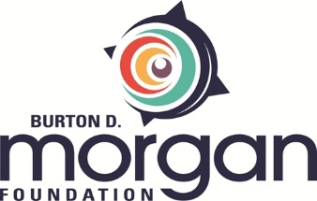
Burton D. Morgan Foundation
Changemaker Grant Request for Proposal
Burton D. Morgan Foundation seeks proposals for the Changemaker Grants, an initiative of the Morgan Scout Fund in celebration of the JumpStart Higher Education Collaboration Council (JSHECC) 10-year anniversary.
The Morgan Scout Fund has been established to encourage proactive and innovative solutions to gaps in the regional entrepreneurial ecosystem. Under this umbrella, the Changemaker Grants will support programs, projects, and research efforts that address gaps in collegiate entrepreneurship in an innovative way. The faculty and staff we encounter in our work are visionaries; many have ideas with the potential to change collegiate entrepreneurship for the better but lack the resources to try such untested and experimental initiatives. The vision of the Morgan Scout Fund Changemaker Grants supports this experimentation in pursuit of bold, inventive, entrepreneurial goals. While proposals may address any number of gap areas, the Foundation is keenly interested in pathways initiatives: work that bridges the transitions between the youth, collegiate, and adult spaces.
Grantees will be expected to actively engage with the JSHECC, including presenting progress, findings, and outcomes at future meetings. Grantees will also contribute to the Foundation’s knowledge sharing work, which may include Lunch and Learns, guest blogs, and presentations at future Board meetings.
Faculty and/or staff from any Northeast Ohio college or university with registered 501(c)3 status are eligible to apply. It is anticipated that five grants of up to $10,000 each will be awarded. Grant period is up to one year. Proposals will be accepted May 20 through September 1, with winners announced at the JSHECC 10-year anniversary celebration on October 23. One proposal per institution will be accepted and should be submitted through the school’s foundation relations office. Applications must be submitted through Morgan Foundation’s online eGrant portal.

