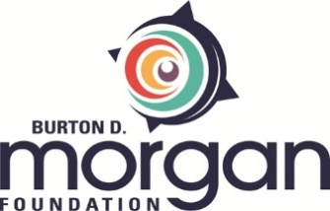

Burton D. Morgan Foundation
Changemaker Grant Application Attachment

To apply for a Changemaker grant, review the RFP on the Apply page of the Foundation’s website to ensure you are eligible. Submit the Grant Application through the online eGrant portal and attach this completed document as the Grant Application instructs. Guidelines for submitting a Grant Application through eGrant can be found on the Apply page of the website.
_____________________________________________________________________________________

- What “gap area” are you seeking to address and why?

- Describe your project in 500 words or less.

- What makes your approach and anticipated outcomes truly innovative? (Please address both).

- What will “success” look like, and how will this be measured or evaluated? Describe your data collection methods.
- Conversely, is there a chance you might fail? What risks exist?
- How will you collaborate with others, both within your institution and outside of it?
- How will you share lessons learned with others? What specific program model, research finding, or other result will your project produce that others can act upon for the overall advancement of collegiate (and, if applicable, youth or adult) entrepreneurship?
- Describe the changemakers behind this project (i.e., your team!). What are your unique strengths, and why are you the right team for the job?

