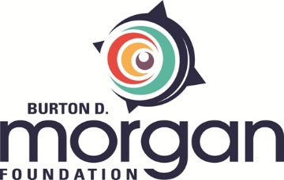

Big Rock Valley Leadership Cohort Application

Burton D. Morgan Foundation is partnering with Edward Lowe Foundation to provide an exceptional growth opportunity to 20 leaders of second-stage companies based in Northeast Ohio.
If selected, you will join a cohort of your peers and attend the Big Rock Valley Leadership Retreat in Michigan, March 21 -23, 2023. Post-retreat, your cohort provides a confidential forum for members to meet virtually to share their challenges and experiences and enhance their leadership capabilities. We are looking for founders and entrepreneurs with an attitude and an aptitude for growth. Expenses to attend the leadership retreat will be paid for by Burton D. Morgan Foundation.
If you are interested and meet the criteria, please complete this form by January 16, 2023, and email it to Gina Dotson at gdotson@bdmorganfdn.org. Expand form as needed to accommodate your responses.

Name: Title:
Email: Phone number:
Business name: Location of business:

- Does your business generate revenues between $1 million and $50 million? Yes_____ No_____

- Does your business employ between 10 and 99 employees? Yes_____ No_____

- Is your business based in Northeast Ohio? Yes_____ No_____

- Are you available to travel to and participate in the Big Rock Valley Leadership Retreat in Michigan March 21 – March 23?
Yes_____ No_____

- Describe the growth you project for your organizational chart over the next three years.

- Describe how this opportunity will catalyze your business’ growth.

- Please indicate if you are affiliated with any of the following:

Bounce_____ Jumpstart_____ Scalerator_____ 10,000 Small Businesses_____

Other________________________________________________

