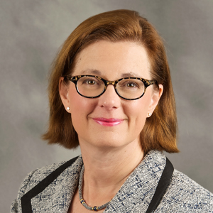
Deborah D. Hoover: Capitalizing on our region’s special sauce
By: Deborah D. Hoover | November 1, 2014

Though a bright light is shining on Northeast Ohio these days, headlines are not all we have to celebrate. Our collective efforts over the last decade have spawned a startup community that is producing inspiring results.
The evolution of our high-energy entrepreneurial ecosystem stems from the roll-up-your-sleeves attitude of people who believe that we can all play a role in designing the future of our region.
And this is where our region’s special sauce enters into the formula.
Northeast Ohio boasts an extraordinary spirit of volunteerism that helps us care for our citizens and strengthen our economy. All over Northeast Ohio talented people are volunteering their time to coach new ventures, judge business plan competitions, mentor college students, offer internships and teach kids about entrepreneurship.
Opportunities for engagement
Brad Feld, author of the book, “Startup Communities,” describes the resources necessary to support a thriving ecosystem. He says we need a continuum of activities and events that engage the entire entrepreneurial stack: things that get first-time entrepreneurs together with experienced entrepreneurs, and investors and aspiring entrepreneurs, and people in big companies who want to work with startups.
Opportunities for such engagement abound in Northeast Ohio. For example, Junior Achievement USA, a volunteer-driven organization offering K-12 level programs focusing on entrepreneurship, financial literacy and work readiness, helps to empower young people to own their economic success.
Andrew Holland, one of JANCO’s most dedicated volunteers, helped launch eyemg, a multimedia division of Publishing Solutions Inc. Holland has been heavily involved as a JANCO volunteer, sharing his experiences as an entrepreneur first in the classroom and later as a team mentor in the JA Titan Challenge, a high school competition aimed at teaching students what it takes to run a successful business.
Holland is passionate about helping young people move from thinking about an idea to saying it out loud and putting their words into action.
“I’m adamant about entrepreneurship,” Holland says. “We were given an (incredible) birthright, being born in the best country in the world to start a business.”

Helping hands
Another compelling story of volunteer mentoring involves Dean Banks, a 29-month charter mentor in JumpStart’s Burton D. Morgan Mentoring Program, and Maurice Bachelor, founder of SnapBatch. Anthony Hughes, founding director of the program, says “in Dean, Maurice found someone who has taken a personal interest in him; yes, as an entrepreneur, but also as a father and a husband, a provider making difficult decisions. Dean has given Maurice perspective and confidence to move forward in tough times to see his dream through. This really is the essence of a great mentor/mentee relationship — empathy, moral support and sage advice from someone who’s been in your shoes.”
So if you have expertise, time to share and a desire to contribute to the economic future of the region, get in touch with your volunteer side and see how you can help.

